**Applications Models**

**Client-server Moel**

Servers:

* Estão sempre ligados
* Endereços IP são sempre o mesmo ou então existe uma associação estática entre um nome e um endereço IP
* Pode agir como cliente e comunicar entre servers

Clientes:

* Comunicam com servers
* Estão ligados quando decorre uma operação
* Podem ter endereços dinâmicos
* 2 modelos
  + Client-server -> neste modelo clientes não comunicam entre sim
  + P2P

**P2P Model**

Clientes:

* Clientes conseguem comunicar entre si
* Estao ligados quando efetuam operações
* Endereços dinâmicos
* Descoberta pode ser feita usando p2p netword ou usando servers centrais

Servers:

* May exist only to bootstrap P2P network(a technique of loading a program into a computer by means of a few initial instructions which enable the introduction of the rest of the program from an input device.)

**VoIP(Voice and vídeo over IP)**

* Network Loss
* Delay Loss
* Loss tolerance
* Requere estabelecimento de sessão
* Protocol SIP(SDP)
* Requerem controlo complexo em larga escala

**SIP- Session Initiation Protocol**

* Criar, modificar, e terminar sessão entre 2 ou mais participantes
* Baseado em texto como http
* Protocolo de transporte em UDP ou TCP
* Protocolo mais simples
* Peer-to-peer protocol (P2P é uma [arquitetura](https://pt.wikipedia.org/wiki/Arquitetura) de [redes de computadores](https://pt.wikipedia.org/wiki/Redes_de_computadores) onde cada um dos pontos ou nós da rede funciona tanto como [cliente](https://pt.wikipedia.org/wiki/Cliente_(computa%C3%A7%C3%A3o)) quanto como [servidor](https://pt.wikipedia.org/wiki/Servidor_(computa%C3%A7%C3%A3o)), permitindo compartilhamentos de serviços e dados sem a necessidade de um servidor central)
* User-agent client (UAC) - A client application that initiates the SIP request.
* User-agent server (UAS) - A server application that contacts the user when a SIP request is received and that returns a response on behalf of the user.
* A SIP endpoint is capable of functioning as both UAC and UAS.

**SIP funcionalidades**

* Suporta 5 facetas para terminar e estabelecer comunicações multimédia
  + User location-determination of the end system to be used for communication;
  + User availability-determination of the willingness of the called party to engage in communications
  + User capabilities-- determination of the media and media parameters to be used
  + Session setup- "ringing", establishment of session parameters at both called and calling party;
  + Session management --including transfer and termination of sessions, modifying session parameters, and invoking services

**SIP CLIENTS**

* Telemóveis
* Gateways
* User agentes
  + Client quando inicia um UAC request
  + Server quando responde a um pedido UAS

**SIP Servers**

* **Proxy Server** 
  + O servidor proxy SIP é o componente que cria a sessão entre os utilizadores, gerando assim a chave de sessão, ou seja, um id ou valor criado para a identificação deste utilizador, fica responsável por alterar os parâmetros para situações novas e informar os utilizadores em sessão destas alterações. Este também é responsável na comunicação inter-domain por validar os certificados digitais de cada um.
  + Receives SIP requests from a client and forwards them on the client’s behalf
  + Receives SIP messages and forward them to the next SIP server in the network
  + Provides functions such as authentication, authorization, network access control, routing, reliable request retransmission, and security.
* **Redirect Server**
  + A diferença entre o servidor proxy e o servidor de reencaminhamento é que o primeiro trata de configurar toda a sessão, ou seja, redireciona o pedido para a entidade seguinte. Enquanto o segundo retorna apenas o endereço que pretendemos obter.
  + Provides the client with information about the next hop or hops that a message should take and then the client contacts the next-hop server or UAS directly.
* **Registrar Server**
  + Processes requests from UACs for registration of their current location.
  + Registrar servers are often co-located with a redirect or proxy server.

**SIP Registrar Server**

* Estes serveres servem para guardar a localização de um endpoint.An endpoint is a remote computing device that communicates back and forth with a network to which it is connected
* A user has an account created which allows them to REGISTER contacts with a particular server.
* The account specifies a SIP “Address of Record (AOR)”
* Each SIP endpoint Registers with a Registrar server with a SIP REGISTER request.
  + Using adress of record
* From: <sip:vieira@192.168.56.102>
* Contact header tells Registrar server where to send messages: From: <sip:vieira@192.168.56.102:5060>
* SIP Proxy servers query SIP Registrar servers for routing information.
* Registration usually requires authentication. If REGISTER has no authentication credential the SIP Registrar server responds with 401 Unauthorized.
* End-point resends REGISTER with an Authorization header with credentials.
* Servers responds with and accepts or rejects

**SIP Messages**

* Comunicação Peer-to-peer apesar de user cliente-server model
* Text-based
* UTF-8
* SIP messages são ou um request from a cliente to a server ou uma resposta de um server para um cliente
  + A request message consists of a Request-Line, one or more header fields, an empty line indicating the end of the header fields, and an optional message-body;
    - A Request-Line contains a Method name, a Request-URI, and SIP-Version separated by a single space (SP) character.
    - RFC 3261 defines six methods: INVITE, ACK, OPTIONS, BYE, CANCEL, and REGISTER.
    - Request-Line: INVITE sip:2001@192.168.56.101 SIP/2.0
    - The remaining of a request message is one or more header fields, an empty line indicating the end of the header fields, and an optional message-body.
  + A response message consists of a Status-Line, one or more header fields, an empty line indicating the end of the header fields, and an optional message-body.
  + All lines (including empty ones) must be terminated by a carriage return line-feed sequence (CRLF).

**SIP requests**

* Tambem são chamados de métodos
* SIP uses SIP Uniform Resource Indicators (URI) to indicate the user or service to which a request is being addressed.
* The general form of a SIP Request-URI is:
  + <sip:user:password@host:port;uri-parameters>
    - sip:John@doe.com
    - <sip:+14085551212@company.com>
    - • <sip:alice@atlanta.com;maddr=239.255.255.1;ttl=15>

**SDP- Session Descripition Protocol**

* SIP encapsula SDP messages
* When initiating multimedia teleconferences, VoIP calls, streaming video, or other sessions, is required to transmit to participants media details, transport addresses, and other session description metadata.
* SDP providencia uma forma de representar essa informação
  + SDP is purely a format for session description.
  + SDP is intended to be general purpose so that it can be used in a wide range of network environments and applications.
  + SDP does not support negotiation of session content or media encodings.

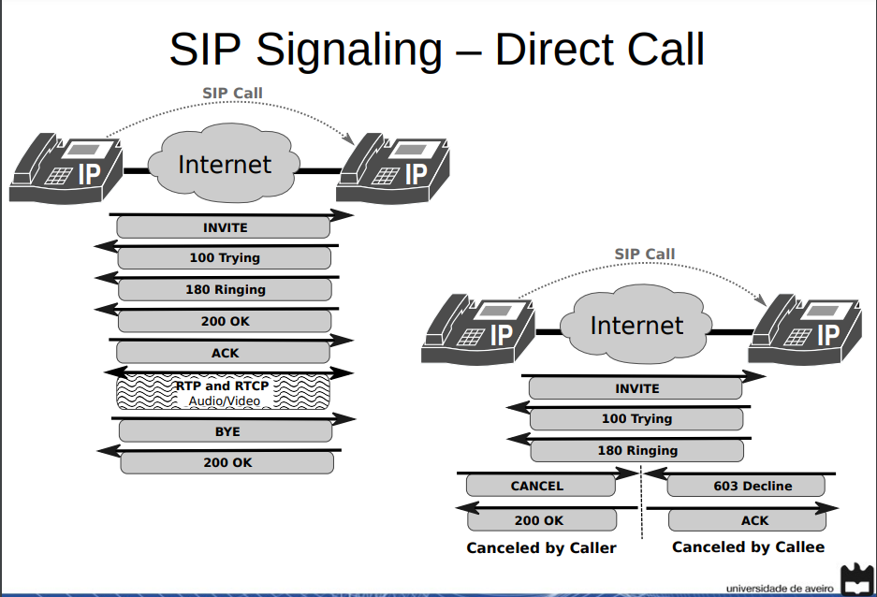

**Locating SIP servers**

* set of DNS procedures to locate SIP Servers.
* elements need to send requests/responses to a resource identified by a SIP URI.
  + Necessita de Transport protocol, IP address and Port.
  + The SIP URI may identify the desired target resource or a intermediate hop towards that resource
  + Otherwise, must be retrieved from a DNS server.
    - Using SRV ou Name authority pointer(records provide a mapping from a domain name to a srv record (server name) and the specific tranport protocol))

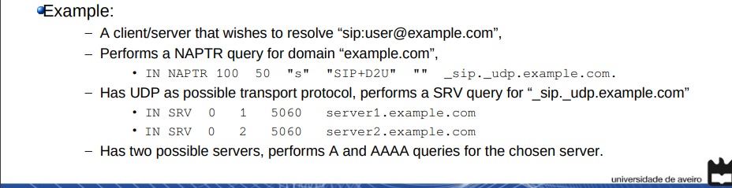

**SIP NAPT Traversal**

* Symmetric Response
* SDP remains unchanged.
* adding a received and rport fields with public address/port.
* SDP contents mismatch with public address/port.
  + Solutions: Let clients (on private network) find out their public address/port and rewrite SDP payload.
  + Symmetric (RTP/RTCP) NAT (RFC 4961).
  + NAT SIP Application Layer Gateway (ALG).

TCP [RFC0793], which is inherently bidirectional, transmits and

receives data using the same local port. That is, when a TCP

connection is established from host A with source TCP port "a" to a

remote host, the remote host sends packets back to host A's source

TCP port "a".

However, UDP is not inherently bidirectional and UDP does not require

using the same port for sending and receiving bidirectional traffic.

Rather, some UDP applications use a single UDP port to transmit and

receive (e.g., DNS [RFC1035]), some applications use different UDP

ports to transmit and receive with explicit signaling (e.g., Trivial

File Transfer Protocol (TFTP) [RFC1350]), and other applications

don't specify the choice of transmit and receive ports (RTP

[RFC3550]).

Because RTP and RTCP are not inherently bidirectional protocols, and

UDP is not a bidirectional protocol, the usefulness of using the same

UDP port for transmitting and receiving has been generally ignored

for RTP and RTCP. Many firewalls, Network Address Translators (NATs)

[RFC3022], and RTP implementations expect symmetric RTP, and do not

work in the presence of asymmetric RTP. However, this term has never

been defined. This document defines "symmetric RTP" and "symmetric

RTCP".

The UDP port number to receive media, and the UDP port to transmit

media are both selected by the device that receives that media and

transmits that media. For unicast flows, the receive port is

communicated to the remote peer

**Symmetric (RTP/RTCP) NAT**

RTP: Este protocolo é entendido como uma rede de ponto-a-ponto, transmitindo dados em tempo real, quer seja em multicast ou unicast. O protocolo RTP consiste em duas partes: o RTP e o Real-time Transport Control Protocol (RTCP) que tem como função obter estatísticas da transferência dos pacotes RTP tais como quantidade de pacotes perdidos e tempos de transferência. O RTP é desenhado para transportar os dados em tempo real, enquanto o RTCP é usado para monitorizar a qualidade do serviço

As aplicações tipicamente correm RTP sobre UDP para fazer uso dos serviços de multiplexagem e checksum, podem também usar outros protocolos como o TCP. No RTP se for usado ao mesmo tempo o áudio e vídeo numa conferência, eles são transmitidos em separado

 the same internal IP address and port, to a specific destination IP address and port, are mapped to the same external IP address

Changes destination address/port to source address/port of received RTP packets

NAT is assumed symetric for RTP

Then, the client would send the learned port+IP via the application (voip) server to the other client, and now that can be used to set up a P2P connection.

**NAT SIP Application Layer Gateway (ALG)**

Translação do pacote SDP

É Pesado

**VoIP and PSTN Connectivity**

* With PSTN interface (to ISP or local PBX).
  + Requires multiple PSTN Lines. •
  + Not scalable.
* With SIP trunk to remote SIP proxy: A maior diferença é que um Tronco SIP elimina a necessidade de um fio físico, permitindo que as empresas façam e recebam ligações usando linhas telefônicas “virtuais” fornecidas por um provedor de tronco SIP. Este provedor usa um circuito de dados de uma empresa (T1, DSL, Wi-Fi) para conectar seu sistema telefônico à rede.
  + Remote proxy/gateway interfaces with PSTN network
  + TCP transport com um layer de segurança
  + Menos custos, mobilidade, fácil gerenciamente, consolidação de rede
  + Scalable!

**WebRTC**

Open source communication technology

Real time áudio and vídeo comunications

* Peer-to-peer connections
* RTP media transport
* Peer to peer data transport
* Peer to peer DTMF